CODEM BOOTCAMP TASK
WEEK – 2
JAVASCRIPT EXERCISES

SUBMITED BY
Vasundhara P S
IT – III Year

GITHUB LINK : https://github.com/vasujoe2005/CodemBootCamp.git

Task 1 – Login Access System
Requirements :
- Create 3 buttons: Admin, User, Guest
- Create validateLogin(username, password)
- On button click:
- Call validateLogin()
- If valid:
- admin → "Full access granted"
- user → "Limited access granted"
- guest → "Read-only access"
- Else → "Invalid credentials"

PROGRAM:
<!DOCTYPE html>
<html>
<head>
<title>Login Access System</title>
<script>
var selectedRole="";
function showLogin(role){
selectedRole=role;
document.getElementById("loginForm").style.display="block";
document.getElementById("result").innerHTML="";
}
function validateLogin(){
var username=document.getElementById("username").value;
var password=document.getElementById("password").value;
var message=document.getElementById("result");

if(selectedRole=="admin" && username=="admin" && password=="123") {
message.innerHTML="Full access granted";
}
else if(selectedRole=="user" && username=="user" && password=="123") {
message.innerHTML="Limited access granted";
}
else if(selectedRole=="guest" && username=="guest" && password=="123") {
message.innerHTML="Read-only access";
}
else{
message.innerHTML="Invalid credentials";
}
}
</script>
</head>

<body>
<h2>Login Access System</h2>
<!-- Role Buttons -->
<button onclick="showLogin('admin')">Admin</button>
<button onclick="showLogin('user')">User</button>
<button onclick="showLogin('guest')">Guest</button>
<br><br>
<!-- Hidden Login Form -->
<div id="loginForm" style="display:none;">
Username: <input type="text" id="username"><br><br>
Password: <input type="password" id="password"><br><br>
<button onclick="validateLogin()">Login</button>
</div>
<h3 id="result"></h3>
</body>
</html>

OUTPUT:
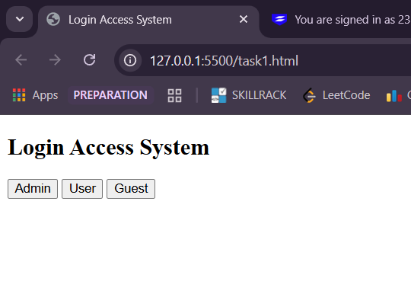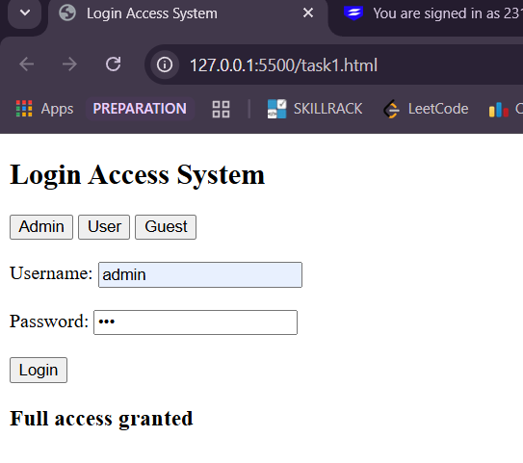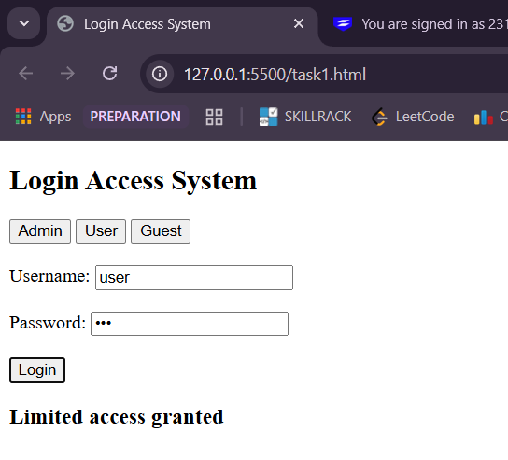
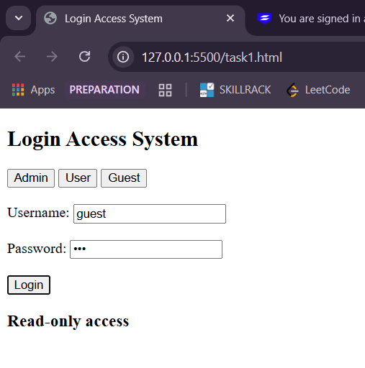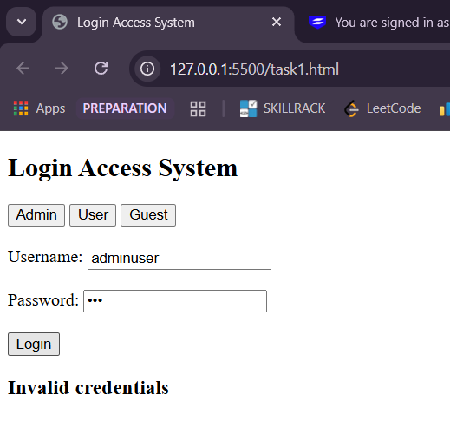

Task 2 – Movie Ticket Permission
Requirements:
- Create 3 buttons: Adult, Teen, Child
- Each button calls checkTicket(age, hasPermission)
- Rules:
- Age 13–17 → allowed only if hasPermission === true
- Others → allowed normally
- Display Allowed / Not Allowed

PROGRAM:
<!DOCTYPE html>
<html>
<head>
<title>Dynamic Ticket Checker</title>
</head>
<body>
<h2>Ticket Eligibility</h2>
<label>Enter Age:</label>
<input type="number" id="ageInput" placeholder="Enter age">
<br><br>
<label>Has Permission?</label>
<select id="permissionInput">
<option value="true">Yes</option>
<option value="false">No</option>
</select>
<br><br>
<button onclick="handleCheck()">Check Ticket</button>
<h3 id="result"></h3>
<script>
function checkTicket(age, hasPermission) {
if (age >= 13 && age <= 17) {
return hasPermission===true ? "Allowed":"Not Allowed";
} else {
return "Allowed";
}
}
function handleCheck() {
const age=parseInt(document.getElementById("ageInput").value);
const hasPermission=document.getElementById("permissionInput").value==="true";

const result=checkTicket(age, hasPermission);

document.getElementById("result").innerText=result;
}
</script>
</body>
</html>

OUTPUT:
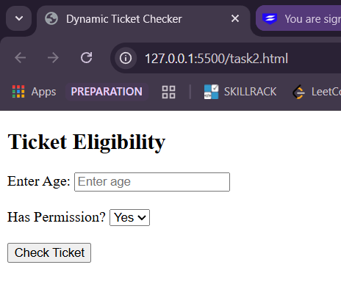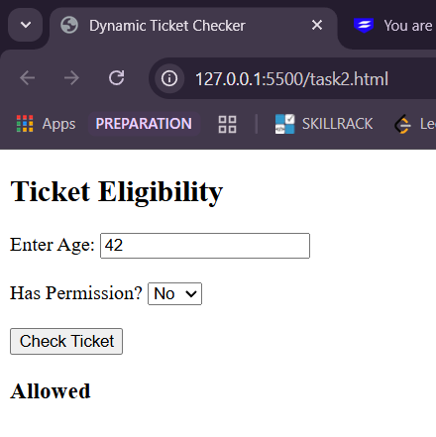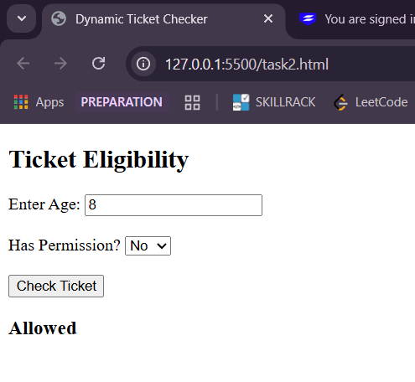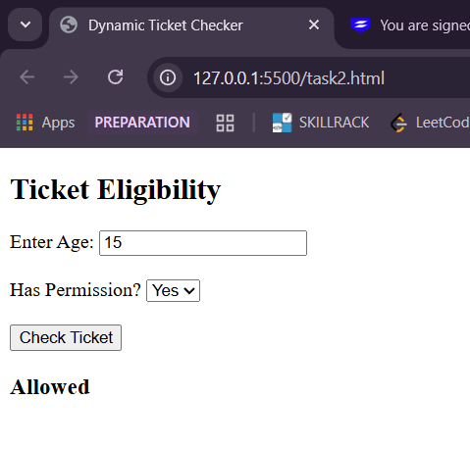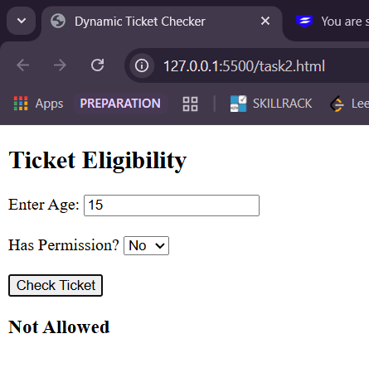

Task 3 – Online Order Status
Requirements :
1. Create checkOrder(isPaid, inStock)
2. Conditions:
3. Paid + In stock → Order confirmed
4. Paid + Out of stock → Order delayed
5. Not paid → Payment required
6. Show result using alert()

PROGRAM:
<!DOCTYPE html>
<html>
<head>
<title>Online Order Status</title>
</head>
<body>
<h2>Check Order Status</h2>
<button onclick="checkOrder(true, true)">Paid + In Stock</button>
<button onclick="checkOrder(true, false)">Paid + Out of Stock</button>
<button onclick="checkOrder(false, true)">Not Paid</button>
<script>
function checkOrder(isPaid, inStock){
if(isPaid && inStock) {
alert("Order Confirmed");
}
else if(isPaid && !inStock) {
alert("Order Delayed");
}
else{
alert("Payment Required");
}
}
</script>
</body>
</html>

OUTPUT:
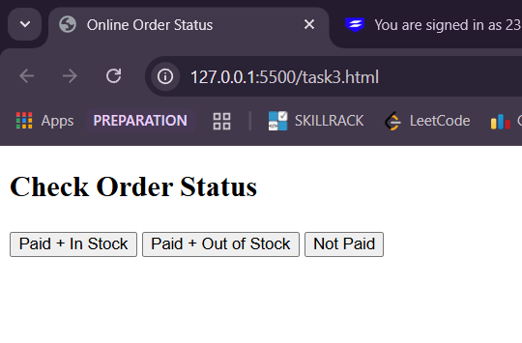
- When Paid + In Stock button pressed:
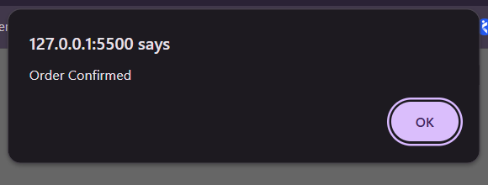
- When Paid + Out Of Stock button pressed:
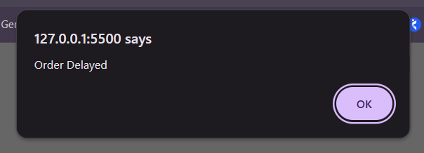
- When Not Paid button pressed:
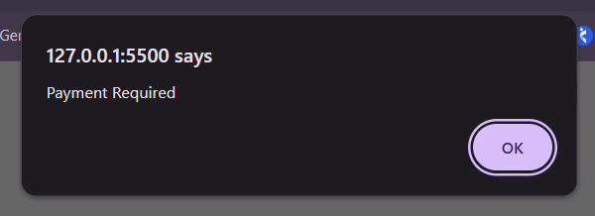

Task 4 – Coin Toss Game
Requirements:
• Create Heads and Tails buttons
• On click:
o Pass player choice to function
o Generate random computer choice
• If both match → Player wins
• Else → Player loses
• Show using alert():
o Player choice
o Computer choice
o Result

PROGRAM:
<!DOCTYPE html>
<html>
<head>
<title>Coin Toss Game</title>
<script>
function tossCoin(playerChoice) {
var randomNumber=Math.random();
var computerChoice;
if(randomNumber < 0.5) {
computerChoice="Heads";
}else{
computerChoice="Tails";
}
var result;
if(playerChoice==computerChoice) {
result="Player wins!";
}else{
result="Player loses!";
}
alert(
"Player choice: " + playerChoice +
"\nComputer choice: " + computerChoice +
"\nResult: " + result
);
}
</script>
</head>
<body>
<h2>Coin Toss Game</h2>
<button onclick="tossCoin('Heads')">Heads</button>
<button onclick="tossCoin('Tails')">Tails</button>
</body>
</html>

OUTPUT:
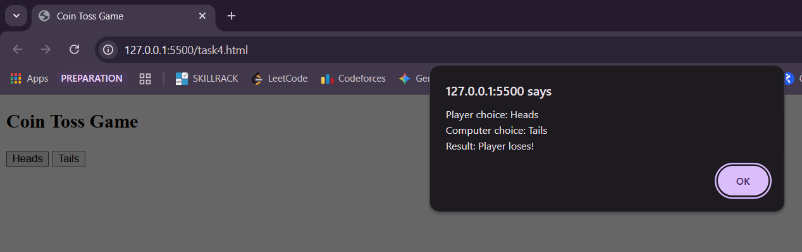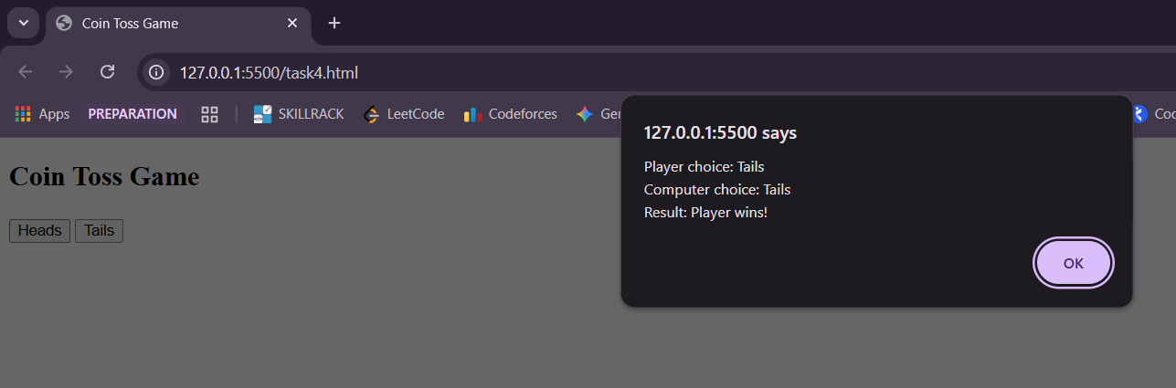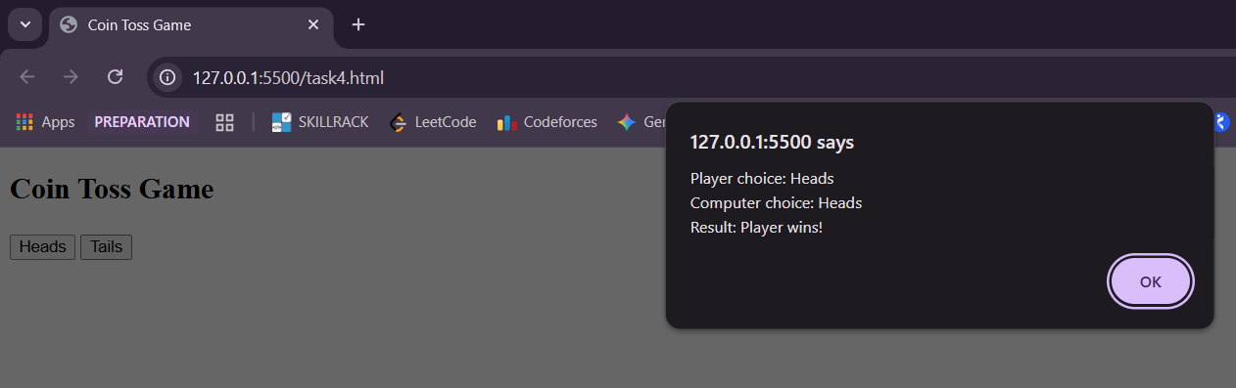
Task 5 – Order & Discount Processor
Requirements :
- Create three buttons to place Small, Medium, and Large orders.
- Each button calls processOrder(orderAmount, isMember, couponCode)
- Create processOrder():
- Validate orderAmount (must be a number > 0).
- Apply discounts:
  - ≥3000 or member → 20%
  - ≥1500 + "SAVE10" → 10%
  - Empty coupon → 0%
  - Else → 5%
- Apply free delivery for final amount ≥2000, else add ₹100.
- Create validateCoupon(couponCode):
- Use console.log() to display order amount, discount %, final amount, delivery status, and coupon validity.
PROGRAM:
<!DOCTYPE html>
<html>
<head>
<title>Order & Discount Processor</title>
<script>
function validateCoupon(couponCode) {
return couponCode=="SAVE10";
}
function processOrder() {
var orderAmount=Number(document.getElementById("amount").value);
var isMember=document.getElementById("member").checked;
var couponCode=document.getElementById("coupon").value;
if(isNaN(orderAmount) || orderAmount<=0) {
console.log("Invalid order amount");
return;
}
var orderType;
if(orderAmount < 1500) {
orderType="Small Order";
}
else if(orderAmount < 3000) {
orderType="Medium Order";
}
else{
orderType="Large Order";
}

var discount=0;
if(orderAmount>=3000 || isMember==true) {
discount=20;
}
else if(orderAmount>=1500 && validateCoupon(couponCode)) {
discount=10;
}
else if(couponCode=="") {
discount=0;
}
else{
discount=5;
}
var finalAmount=orderAmount-(orderAmount * discount / 100);
var deliveryStatus;
if(finalAmount>=2000) {
deliveryStatus="Free Delivery";
}else{
finalAmount=finalAmount+100;
deliveryStatus="₹100 Delivery Charge Added";
}
console.log("Order Type:", orderType);
console.log("Order Amount: ₹"+orderAmount);
console.log("Member Status:", isMember ? "Member" : "Not a Member");
console.log("Delivery Status:", deliveryStatus);
console.log("Discount Applied: "+discount+"%");
console.log("Final Amount: ₹"+finalAmount);
console.log("Coupon Valid:", validateCoupon(couponCode));
}
</script>
</head>
<body>
<h2>Order & Discount Processor</h2>
Enter Order Amount: <input type="number" id="amount"><br><br>
Member: <input type="checkbox" id="member"> <br><br>
Coupon Code: <input type="text" id="coupon"><br><br>
<button onclick="processOrder()">Place Order</button>
</body>
</html>

OUTPUT:
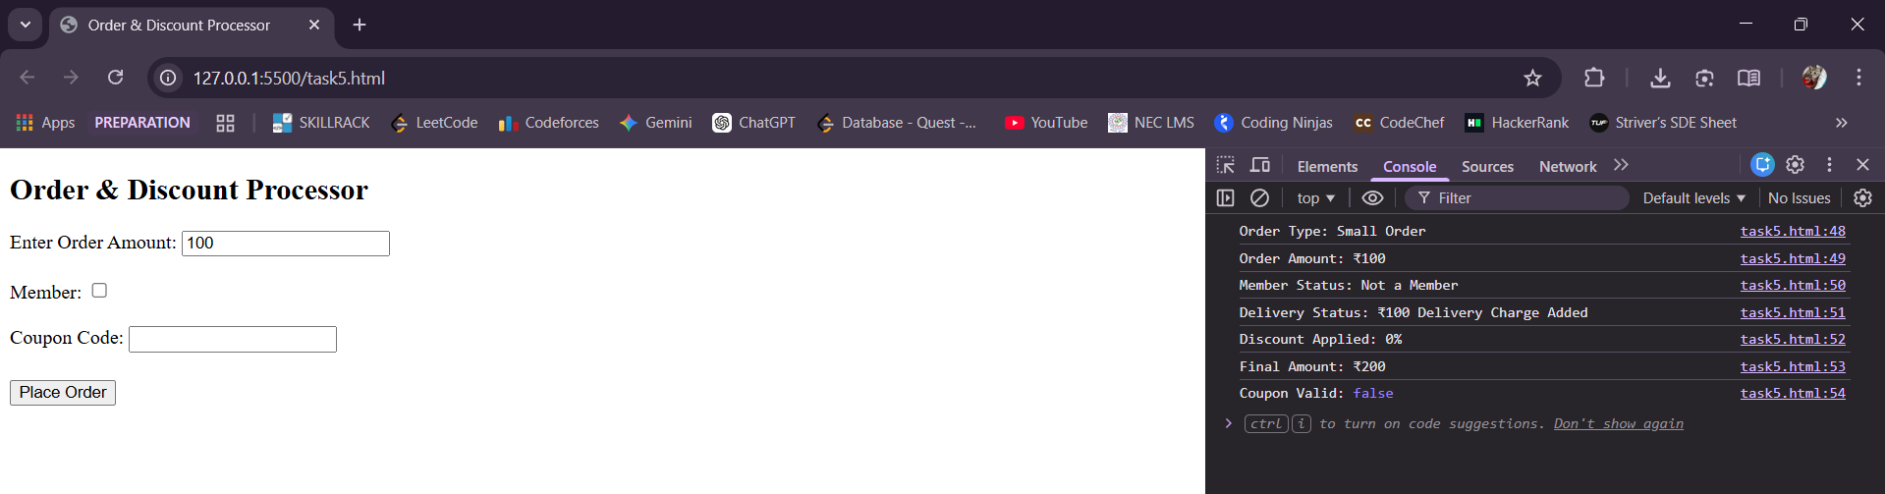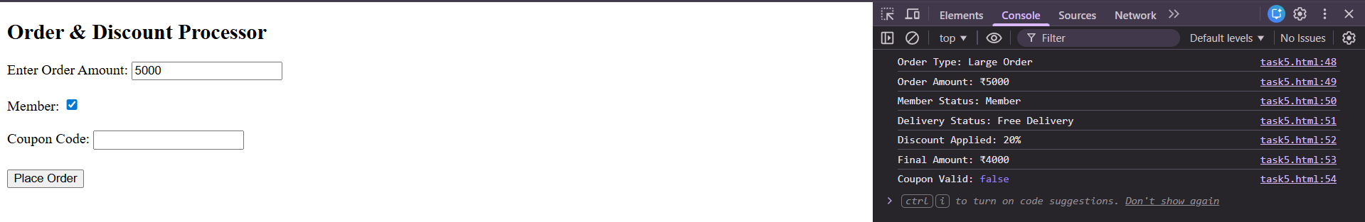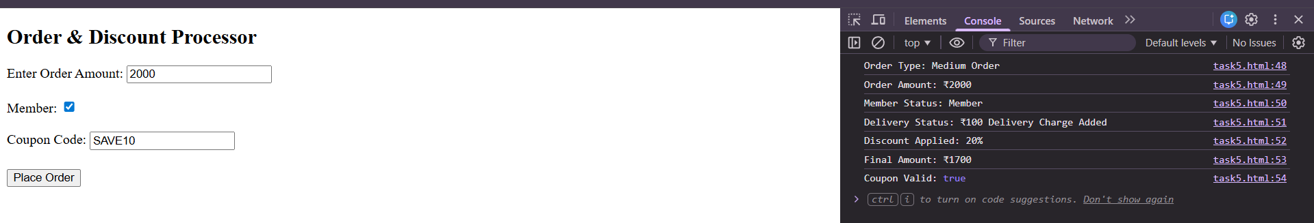
Task 6 – Simple Billing System
Requirements :
- Create Buttons: Regular, Member
- Call calculateBill(billAmount, isMember)
- If billAmount ≤ 0 → log error & stop
- Discounts:
  - Member → 10%
  - Bill ≥1000 → 5%
  - Else → 0%
- Gift:
  - Final ≥1500 → Free gift
- Display all details

PROGRAM:
<!DOCTYPE html>
<html>
<head>
<title>Simple Billing System</title>
<script>
function calculateBill(isMember) {
var billAmount=Number(document.getElementById("bill").value);
if(isNaN(billAmount) || billAmount<=0) {
console.log("Error: Invalid bill amount");
return;
}
var discountPercent=0;
if(isMember==true) {
discountPercent=10;
}
else if(billAmount>=1000) {
discountPercent=5;
}
else{
discountPercent=0;
}
var discountAmount=(billAmount * discountPercent) / 100;
var finalAmount=billAmount-discountAmount;
var giftStatus;
if(finalAmount>=1500) {
giftStatus="Free Gift Eligible";
}else{
giftStatus="No Free Gift";
}

console.log("Bill Amount: ₹"+billAmount);
console.log("Customer Type:", isMember ? "Member" : "Regular");
console.log("Discount Applied: "+discountPercent+"%");
console.log("Discount Amount: ₹"+discountAmount);
console.log("Final Amount: ₹"+finalAmount);
console.log("Gift Status:", giftStatus);
}
</script>
</head>
<body>
<h2>Simple Billing System</h2>
Enter Bill Amount: <input type="number" id="bill"><br><br>
<button onclick="calculateBill(false)">Regular</button>
<button onclick="calculateBill(true)">Member</button>
</body>
</html>

OUTPUT:
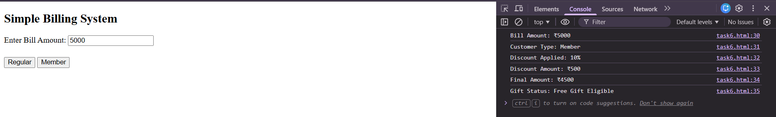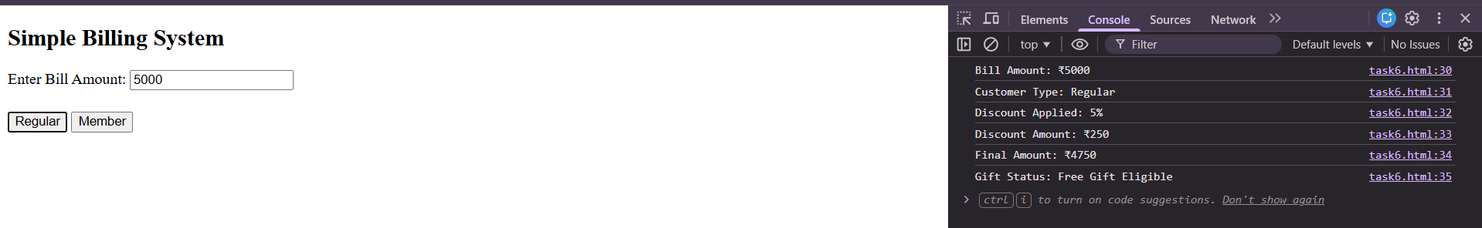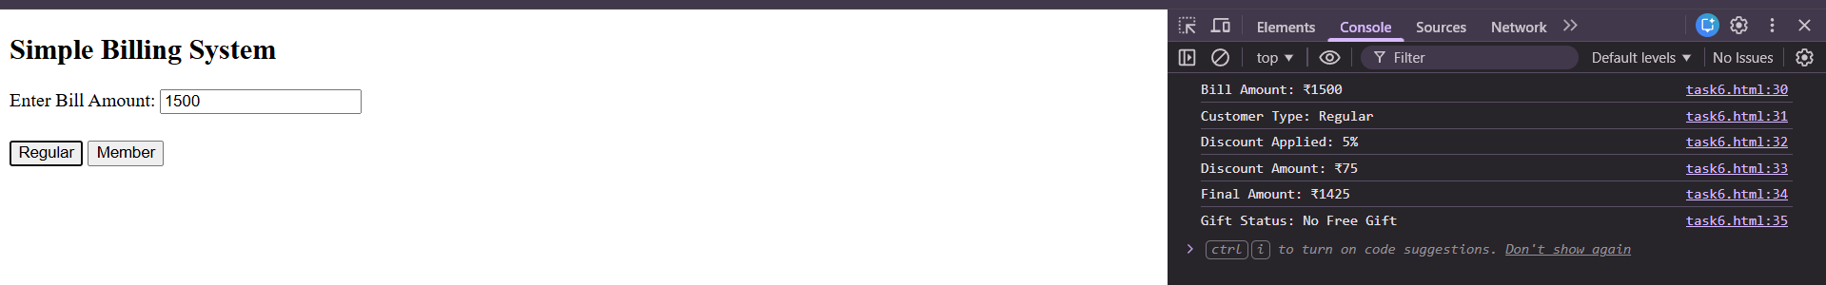
Task 7 – Travel Eligibility Checker
Requirements :
- Create checkTravelEligibility(age, ticketType, hasID).
- If age <= 0 → "Invalid age" and return.
- If ticketType not "normal" or "priority" → "Invalid ticket type" and return.
- Eligibility:
  - age >= 18 and hasID → Eligible
  - age < 18 and "priority" ticket → Eligible with guardian
  - Else → Not eligible
- Fare:
  - Base fare = ₹200
  - "priority" → add ₹50
- Log eligibility, fare, ticket type, age check

PROGRAM:
<!DOCTYPE html>
<html>
<head>
<title>Travel Eligibility Checker</title>
<script>
function checkTravelEligibility() {
var age=Number(document.getElementById("age").value);
var ticketType=document.getElementById("ticketType").value.toLowerCase();
var hasID=document.getElementById("hasID").checked;
if(age<=0 || isNaN(age)) {
console.log("Invalid age");
return;
}
if(ticketType !== "normal" && ticketType !== "priority") {
console.log("Invalid ticket type");
return;
}
var eligibility;
if(age>=18 && hasID) {
eligibility="Eligible";
}
else if(age < 18 && ticketType==="priority") {
eligibility="Eligible with Guardian";
}
else{
eligibility="Not Eligible";
}
var fare=200;

if(ticketType==="priority") {
fare += 50;
}
console.log("Age:", age);
console.log("Ticket Type:", ticketType);
console.log("Has ID:", hasID ? "Yes" : "No");
console.log("Eligibility:", eligibility);
console.log("Total Fare: ₹"+fare);
}
</script>
</head>
<body>
<h2>Travel Eligibility Checker</h2>
Enter Age: <input type="number" id="age"><br><br>
Ticket Type:
<select id="ticketType">
<option value="normal">Normal</option>
<option value="priority">Priority</option>
</select>
<br><br>
Has Valid ID:<input type="checkbox" id="hasID"> <br><br>
<button onclick="checkTravelEligibility()">Check Eligibility</button>
</body>
</html>

OUTPUT:
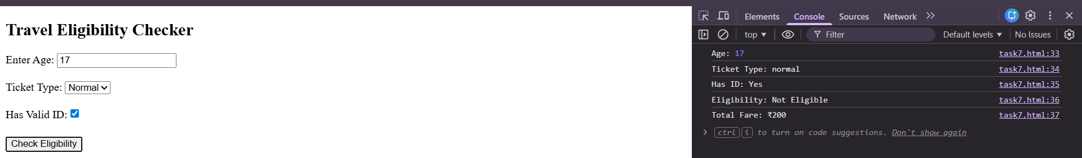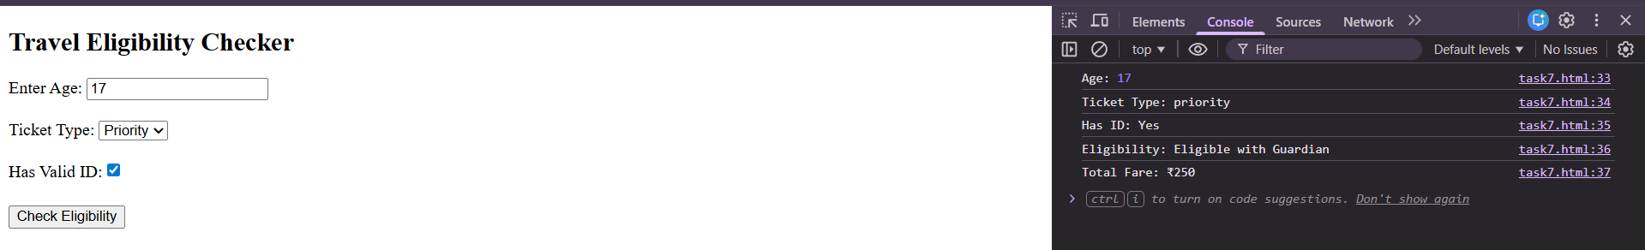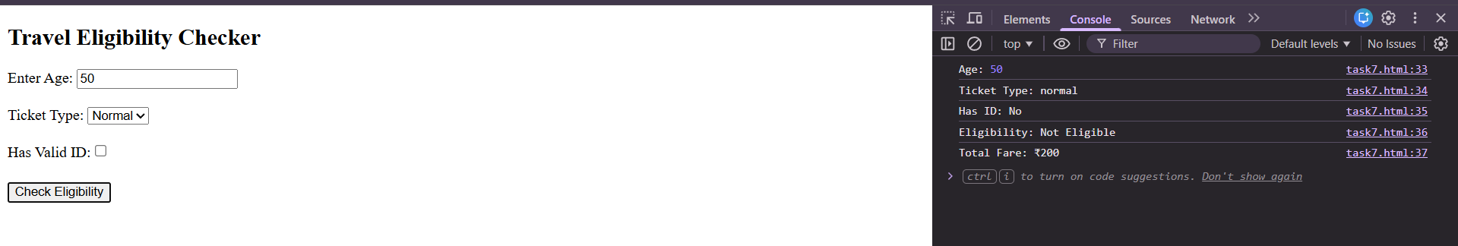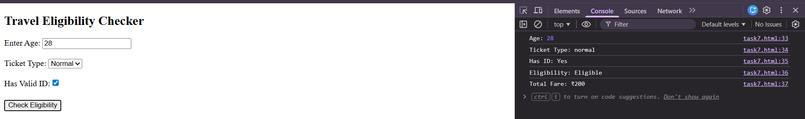

Task 8 – Message Priority Formatter
Requirements:
- Create processMessage(message, isUrgent).
- Validate: If message is empty → "Message cannot be empty" and return.
- Create booleans:
  - hasWarningWord → message includes "error" or "fail".
  - isHighPriority → isUrgent OR hasWarningWord.
- Message formatting:
  - If high priority → uppercase + " IMPORTANT: "
  - Else → lowercase + "INFO: "
- Display: Final message and High-priority status

PROGRAM:
<!DOCTYPE html>
<html>
<head>
<title>Message Priority Formatter</title>
<script>
function processMessage() {
var message=document.getElementById("message").value;
var isUrgent=document.getElementById("urgent").checked;
if(message.trim()==="") {
console.log("Message cannot be empty");
return;
}

var lowerMessage=message.toLowerCase();
var hasWarningWord=lowerMessage.includes("error")||lowerMessage.includes("fail");
var isHighPriority=isUrgent || hasWarningWord;
var finalMessage;
if(isHighPriority) {
finalMessage="IMPORTANT: "+message.toUpperCase();
}else{
finalMessage="INFO: "+message.toLowerCase();
}
console.log("Original Message:", message);
console.log("Urgent:", isUrgent ? "Yes" : "No");
console.log("Contains Warning Word:", hasWarningWord);
console.log("High Priority:", isHighPriority ? "Yes" : "No");
console.log("Final Message:", finalMessage);
}
</script>
</head>
<body>
<h2>Message Priority Formatter</h2>
Enter Message:<br><textarea id="message" rows="4" cols="40"></textarea>
<br><br>
Mark as Urgent:<input type="checkbox" id="urgent">
<br><br>
<button onclick="processMessage()">Process Message</button>
</body>
</html>

OUTPUT: 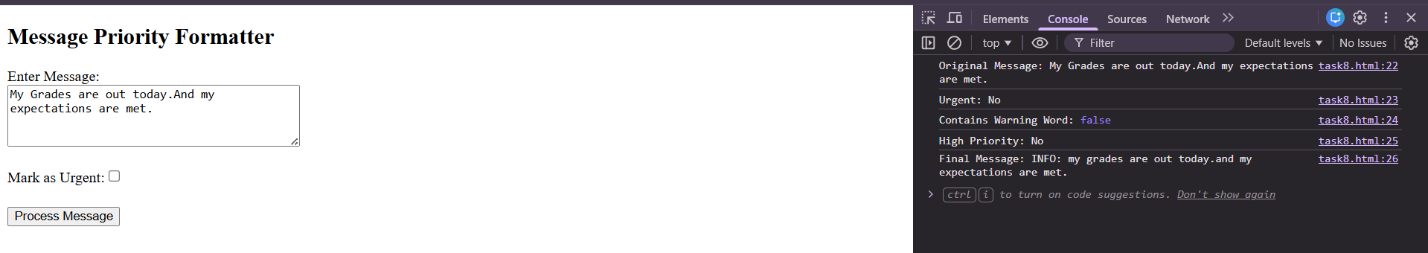
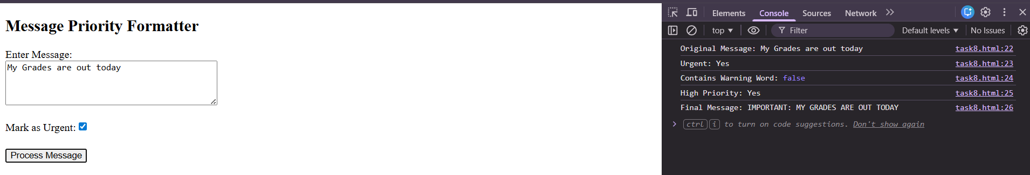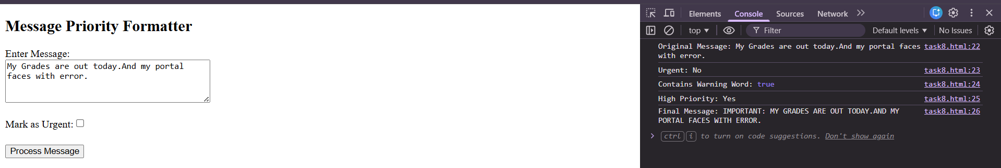

Task 9 – Message Intent Detection
Requirements:
- Create a function detectIntent(message).
- Validate empty or spaces → Invalid
- Flags
  - isQuestion → message contains ?
  - isComplaint → message contains "problem" or "not working"
- Intent
  - Question + complaint → Urgent request
  - Complaint → Complaint
  - Question → Question
  - Else → Other
- Log intent and original message using console.log()

PROGRAM:
<!DOCTYPE html>
<html>
<head>
<title>Message Intent Detection</title>
<script>
function detectIntent() {
var message=document.getElementById("message").value;
if(message.trim()==="") {
console.log("Invalid message");
return;
}
var lowerMessage=message.toLowerCase();
var isQuestion=lowerMessage.includes("?");
var isComplaint=
lowerMessage.includes("problem") ||
lowerMessage.includes("not working");

var intent;
if(isQuestion && isComplaint) {
intent="Urgent Request";
}
else if(isComplaint) {
intent="Complaint";
}
else if(isQuestion) {
intent="Question";
}
else{
intent="Other";
}
console.log("Original Message:", message);
console.log("Intent:", intent);
}
</script>
</head>

<body>
<h2>Message Intent Detection</h2>
Enter Message:<br><textarea id="message" rows="4" cols="40"></textarea>
<br><br>
<button onclick="detectIntent()">Detect Intent</button>
</body>
</html>

OUTPUT:
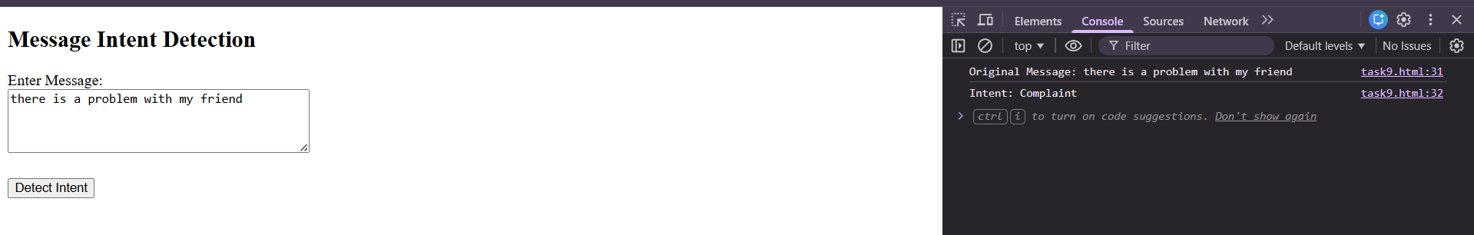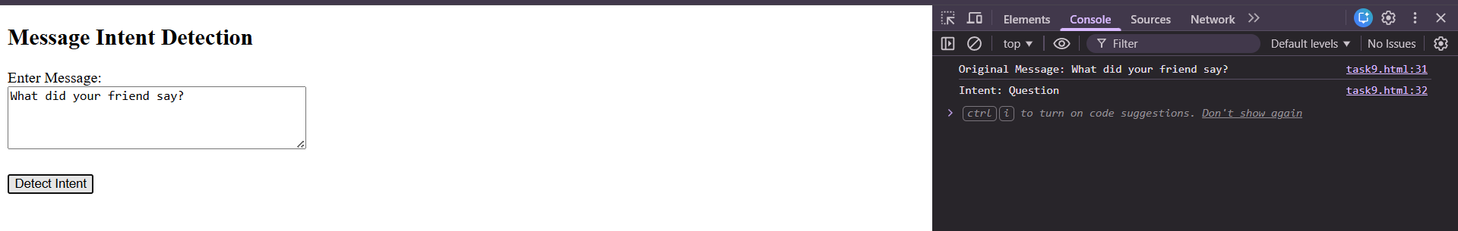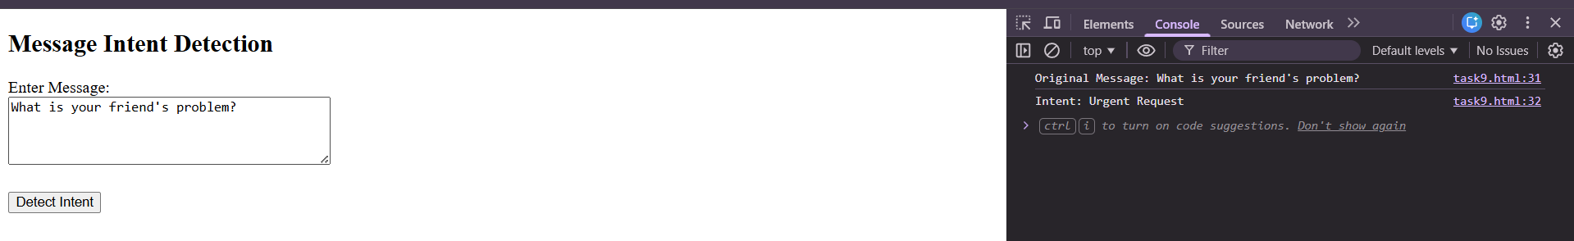

Task 10 – Account Security Check
Requirements:
- Check account access using password status, OTP verification, and account block status.
- Allow login only if all conditions are valid.
- Display login success or failure message.

PROGRAM:
<!DOCTYPE html>
<html>
<head>
<title>Account Security Check</title>
<script>
function checkAccountSecurity() {
var passwordStatus=document.getElementById("passwordStatus").value;
var otpStatus=document.getElementById("otpStatus").value;
var accountStatus=document.getElementById("accountStatus").value;
var result=document.getElementById("result");
if(passwordStatus==="correct" && otpStatus==="verified" && accountStatus==="active"){
result.innerHTML="Login Successful";
}
else{
result.innerHTML="Login Failed";
}
}
</script>
</head>

<body>
<h2>Account Security Check</h2>
Password Status:
<select id="passwordStatus">
<option value="correct">Correct</option>
<option value="wrong">Wrong</option>
</select>
<br><br>
OTP Verification:
<select id="otpStatus">
<option value="verified">Verified</option>
<option value="notVerified">Not Verified</option>
</select>
<br><br>
Account Status:
<select id="accountStatus">
<option value="active">Active</option>
<option value="blocked">Blocked</option>
</select>
<br><br>
<button onclick="checkAccountSecurity()">Login</button>
<h3 id="result"></h3>
</body>
</html>

OUTPUT:

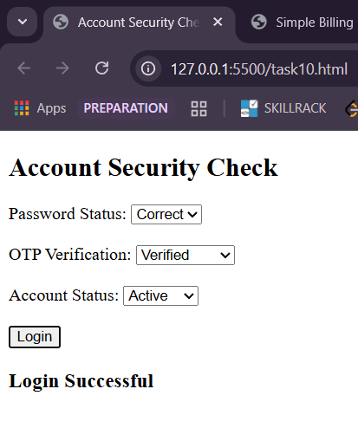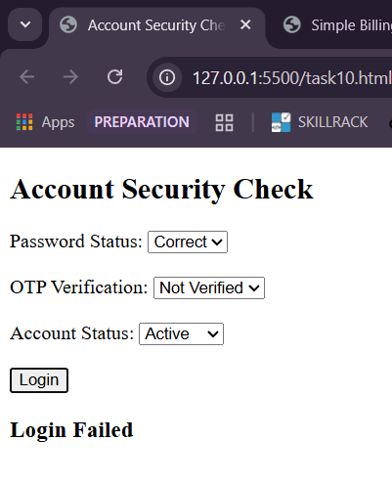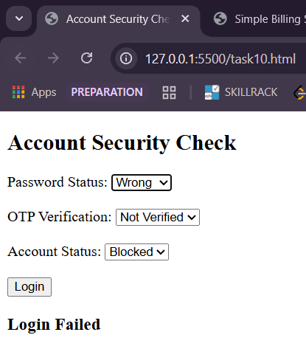

Task 11 – Weather Action Advisor
Requirements:
- Check weather condition (rainy/sunny/etc.) and temperature.
- Suggest an action (carry umbrella, stay hydrated, etc.).
- Display the suggestion using alert().

PROGRAM:
<!DOCTYPE html>
<html>
<head>
<title>Weather Action Advisor</title>
<script>
function checkWeather(){
var weather=document.getElementById("weather").value.toLowerCase();
var temperature=Number(document.getElementById("temp").value);
var suggestion="";
if(weather==="rainy") {
suggestion="Carry an umbrella.";
}
else if(weather==="sunny") {
suggestion="Wear sunglasses.";
}
else if(weather==="cold") {
suggestion="Wear warm clothes.";
}
else{
suggestion="Have a good day.";
}
if(temperature > 35) {
suggestion += "Stay hydrated.";
}
else if(temperature < 15) {
suggestion += "Keep yourself warm.";
}
else{
suggestion += "Weather looks comfortable.";
}
alert("Weather: "+weather+"\nTemperature: "+temperature+"°C"+"\nSuggestion: "+suggestion);
}
</script>
</head>
<body>
<h2>Weather Action Advisor</h2>
Weather Condition:
<select id="weather">
<option value="sunny">Sunny</option>
<option value="rainy">Rainy</option>
<option value="cold">Cold</option>
<option value="cloudy">Cloudy</option>
</select>
<br><br>

Temperature (°C):
<input type="number" id="temp">
<br><br>
<button onclick="checkWeather()">Get Advice</button>
</body>
</html>

OUTPUT:

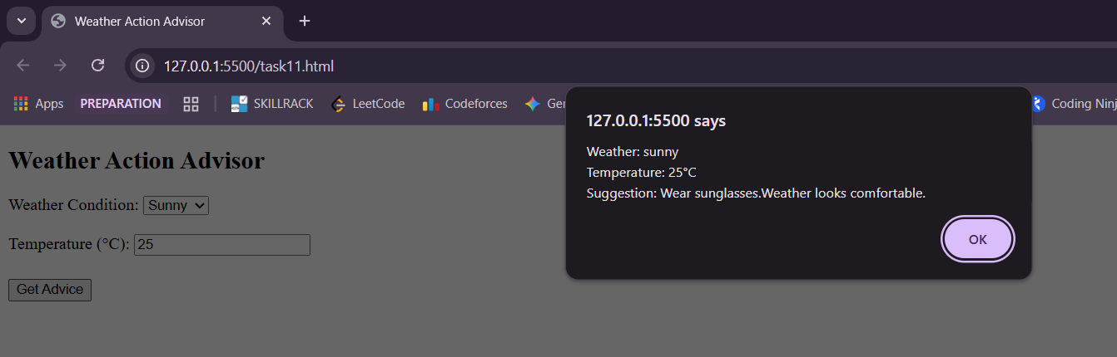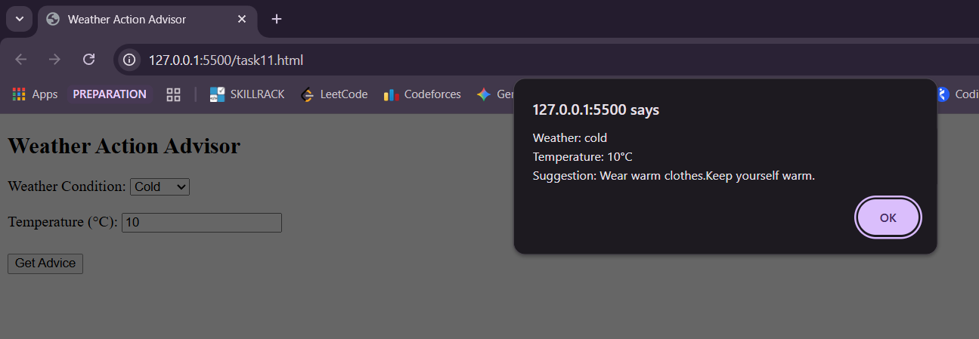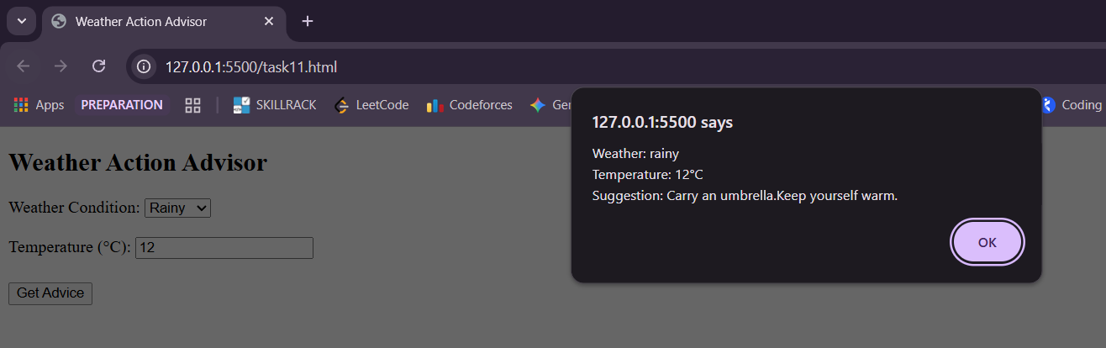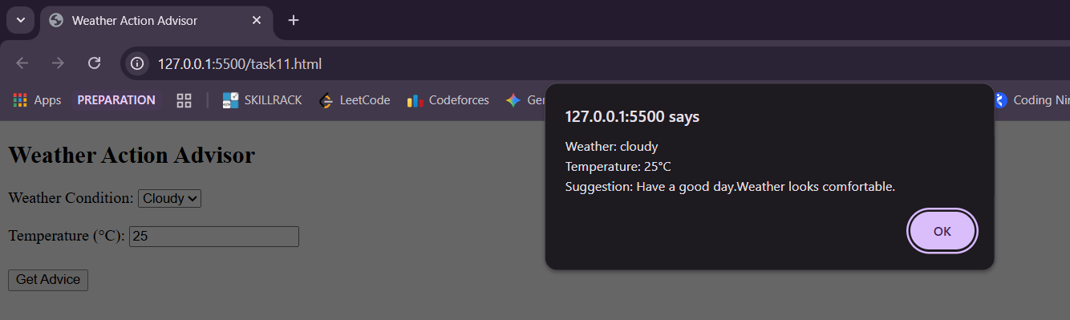

Task 12 – Password Strength Validator
Requirements:
- Create a function to check password content (length, characters).
- Classify password as Weak, Medium, or Strong.
- Display the strength result.

PROGRAM:
<!DOCTYPE html>
<html>
<head>
<title>Password Strength Validator</title>
<script>
function checkPassword(){
var password = document.getElementById("password").value;
var result = document.getElementById("result");
var lengthCheck = password.length >= 8;
var upperCheck = /[A-Z]/.test(password);
var lowerCheck = /[a-z]/.test(password);
var numberCheck = /[0-9]/.test(password);
var specialCheck = /[!@#$%^&*]/.test(password);
var noSpaceCheck = !/\s/.test(password);
var score = 0;
if (lengthCheck) score++;
if (upperCheck) score++;
if (lowerCheck) score++;
if (numberCheck) score++;
if (specialCheck) score++;
if (noSpaceCheck) score++;
var strength;
if (score <= 2) {
strength = "Weak";
result.style.color = "red";
}
else if (score <= 5) {
strength = "Medium";
result.style.color = "orange";
}
else {
strength = "Strong";
result.style.color = "green";
}
result.innerHTML = "Password Strength: " + strength;
}
</script>
</head>
<body>
<h2>Password Strength Validator</h2>
Enter Password:
<input type="text" id="password" onkeyup="checkPassword()">
<br><br>
<h3 id="result"></h3>
</body>
</html>

OUTPUT:

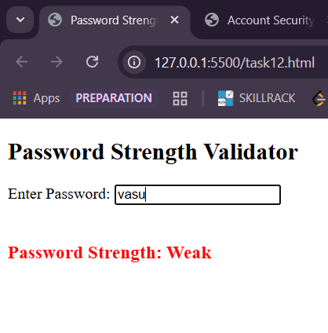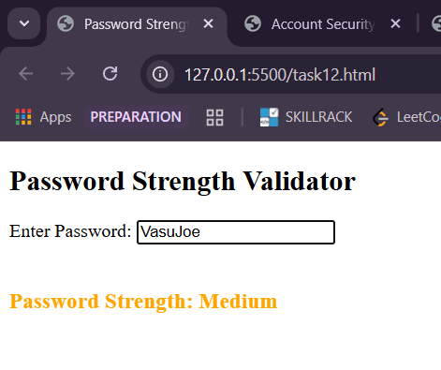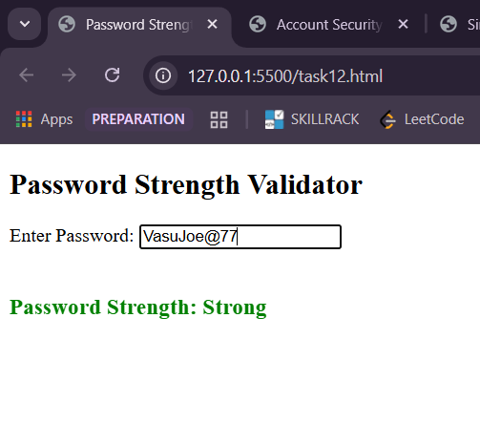
Task 13 – Appointment Confirmation System
Requirements:
- Create checkAppointment(dateAvailable, userConfirmed).
  - If dateAvailable is false → "Appointment Rejected"
  - Else if userConfirmed is false → "Appointment Rejected"
  - Else → "Appointment Confirmed"
- Display Confirmed or Rejected status using alert().

PROGRAM:
<!DOCTYPE html>
<html>
<head>
<title>Appointment Confirmation System</title>
<script>
function checkAppointment(){
var dateAvailable=document.getElementById("dateAvailable").value;
var userConfirmed=document.getElementById("userConfirmed").value;
if(dateAvailable==="false") {
alert("Appointment Rejected");
}
else if(userConfirmed==="false") {
alert("Appointment Rejected");
}
else{
alert("Appointment Confirmed");
}
}
</script>
</head>
<body>
<h2>Appointment Confirmation System</h2>
Date Available:
<select id="dateAvailable">
<option value="true">Available</option>
<option value="false">Not Available</option>
</select>
<br><br>

User Confirmation:
<select id="userConfirmed">
<option value="true">Confirmed</option>
<option value="false">Not Confirmed</option>
</select>
<br><br>
<button onclick="checkAppointment()">Check Appointment</button>
</body>
</html>

OUTPUT:

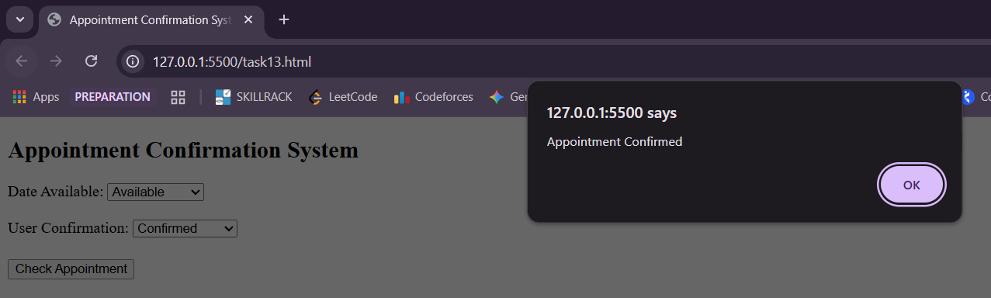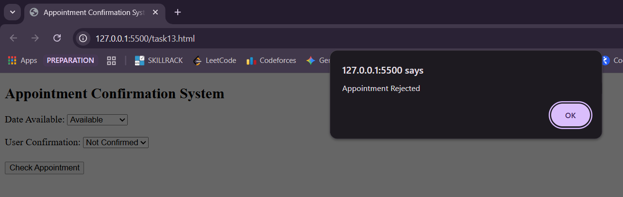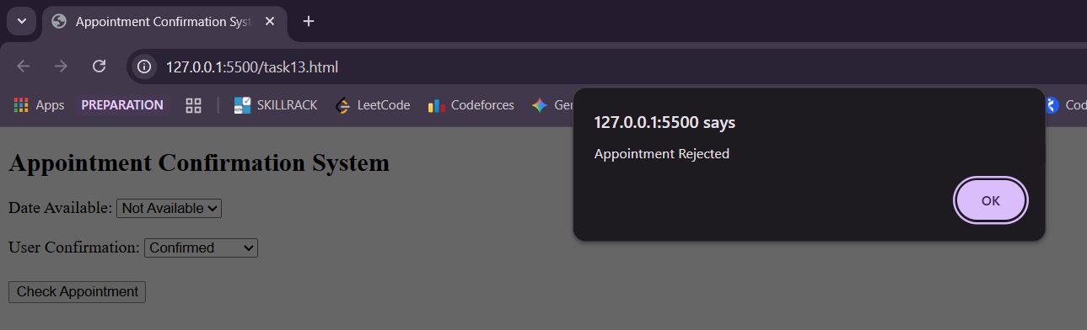

Task 14 – Notification Filter
Requirements:
- Check notification message content and urgency flag.
- Classify notification as Important or Normal.
- Display notification type with formatted message.

PROGRAM:
<!DOCTYPE html>
<html>
<head>
<title>Notification Filter</title>
<script>
function filterNotification(){
var message=document.getElementById("message").value;
var isUrgent=document.getElementById("urgent").checked;
var result=document.getElementById("result");
var lowerMessage=message.toLowerCase();
var hasImportantWord=lowerMessage.includes("error")||lowerMessage.includes("alert")||lowerMessage.includes("urgent");
var isImportant=isUrgent||hasImportantWord;
var formattedMessage;
if(isImportant){
formattedMessage="IMPORTANT: "+message.toUpperCase();
}else{
formattedMessage="NORMAL: "+message;
}
result.innerHTML ="<strong>Notification Type:</strong> "+(isImportant ? "Important" : "Normal")+"<br><br>"+formattedMessage;
}
</script>
</head>
<body>
<h2>Notification Filter</h2>
Enter Notification Message:<br>
<textarea id="message" rows="4" cols="40"></textarea>
<br><br>
Mark as Urgent:
<input type="checkbox" id="urgent">
<br><br>
<button onclick="filterNotification()">Check Notification</button>
<br><br>
<div id="result"></div>
</body>
</html>

OUTPUT:

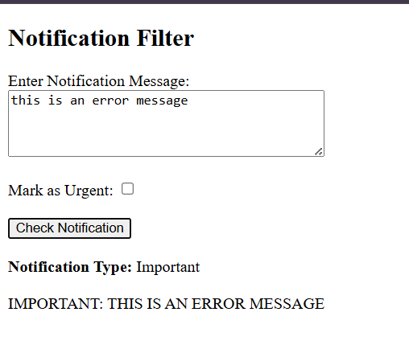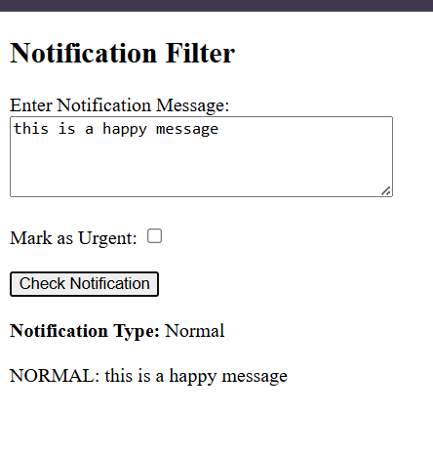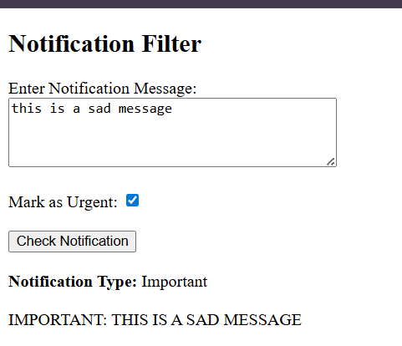

Task 15 – Payment Status Checker
Requirements:
- Create checkPaymentStatus(amount, isPaid, paymentMethod).
- If amount <= 0 → "Invalid payment amount"
- Else if isPaid is false → "Payment Pending"
- Else if paymentMethod is "UPI" or "Card" → "Payment Successful"
- Else → "Invalid payment method"
- Display: Payment status , Amount and Payment Method

PROGRAM:
<!DOCTYPE html>
<html>
<head>
<title>Payment Status Checker</title>
<script>
function checkPaymentStatus(){
var amount=Number(document.getElementById("amount").value);
var isPaid=document.getElementById("isPaid").value;
var paymentMethod=document.getElementById("method").value;
var result=document.getElementById("result");
var status;
if(isNaN(amount)||amount <= 0){
status="Invalid payment amount";
}
else if(isPaid==="false"){
status="Payment Pending";
}
else if(paymentMethod==="UPI"||paymentMethod==="Card"){
status="Payment Successful";
}
else{
status="Invalid payment method";
}
result.innerHTML="<strong>Payment Status:</strong> "+status+"<br><strong>Amount:</strong> ₹"+amount+"<br><strong>Payment Method:</strong> "+paymentMethod;
}
</script>
</head>
<body>
<h2>Payment Status Checker</h2>
Enter Amount: <input type="number" id="amount"><br><br>
Payment Done:
<select id="isPaid">
<option value="true">Yes</option>
<option value="false">No</option>
</select>
<br><br>
Payment Method:
<select id="method">
<option value="UPI">UPI</option>
<option value="Card">Card</option>
<option value="Cash">Cash</option>
</select>
<br><br>

<button onclick="checkPaymentStatus()">Check Payment</button>
<br><br>
<div id="result"></div>
</body>
</html>

OUTPUT:

